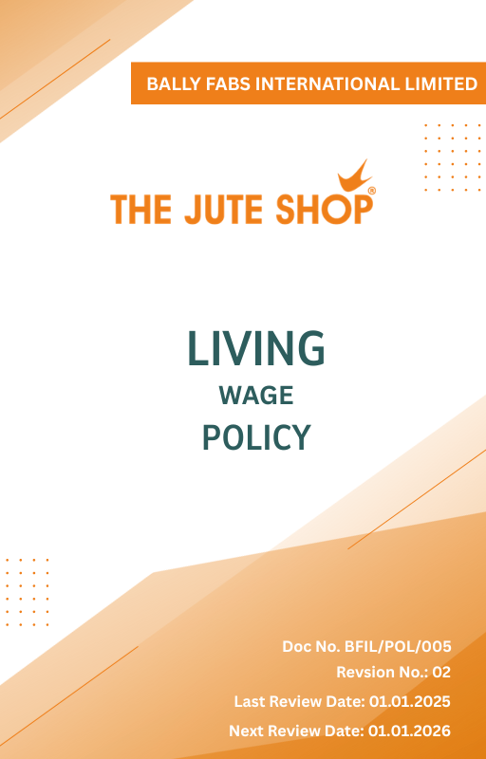
Contents

Introduction 3
Scope 3
Policy Statement 3
Key Focus Areas 3
Our Objectives & Targets 4
Alignment with the United Nations Sustainable Development Goals (SDGs) 5
Responsibilities 5
Review Mechanism 5
Employee Acknowledgment Form 6

Introduction
At Bally Fabs International Ltd. we are committed to ensuring that every employee receives fair compensation that meets their basic needs and supports a dignified standard of living. Our Living Wage Policy reflects our dedication to social responsibility and the well-being of our workforce. By implementing this policy, we aim to create a more inclusive and equitable workplace, fostering a sustainable and thriving business environment.

Scope
This policy applies to all workers, employees, directors, officers, agents, contractors, and any third parties acting on behalf of Bally Fabs Int. Ltd. (BIFL). It covers all business activities, including procurement, sales, marketing, and any interactions with government officials, customers, suppliers, and other stakeholders. The policy is applicable globally, regardless of local business practices or cultural norms. This policy applies to the below mentioned locations:

Site | Address
Bally Fabs International Limited | - 3, Haren Mukherjee Road, Belur, Howrah-711202, West Bengal, India.
Bally Fabs International Limited | - Vill-gangarampur, PO-Dakshin Alipore, ps-Bishnupur, Dist-South 24 Parganas, Pin-743503, West Bengal, India

Policy Statement
Bally Fabs International Ltd. is committed to provide all employees with a living wage that ensures their basic needs are met and supports a dignified quality of life. We believe that fair compensation is fundamental to our employees' well-being and the long-term success of our business. This policy is a key component of our commitment to social responsibility, equity, and respect for all members of our workforce. We pledge to regularly review and adjust wages to align with the cost of living, ensuring that our employees are fairly compensated for their contributions.

Key Focus Areas
- Regularly evaluate wage levels against living wage benchmarks.
- Implement necessary revisions to align wages with inflation, cost of living changes, and industry standards.
- Engage with suppliers to promote and uphold living wage practices throughout the value chain.
- Collaborate with employees, industry bodies, and labor organizations to refine wage policies.
- Maintain clear documentation of wage structures, conduct periodic audits, and report progress.

Our Objectives & Targets
- Ensure that by 2030, 100% of employees, including full-time, part-time, and contract workers, receive their full wages on time, without delays, and at levels that meet or exceed living wage standards.
- Maintain Zero identified living wage gaps till year 2030 through structured wage adjustments and periodic reviews.
- Conduct annual wage assessments to align salaries with inflation, cost-of-living changes, and industry benchmarks.
- Integrate living wage criteria into supplier audits and procurement policies to encourage responsible sourcing ensure it’s compliance by year 2030.

Alignment with the United Nations Sustainable Development Goals (SDGs)
The sustainability objectives and performance targets align with the following Sustainable Development Goals (SDGs):
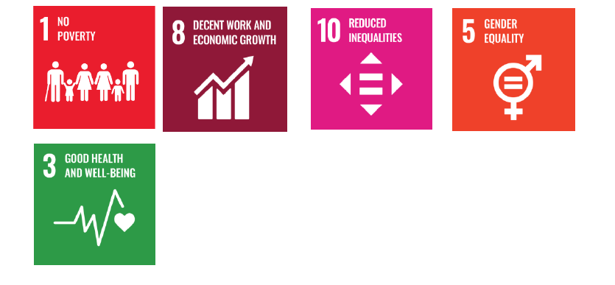

Responsibilities
At Bally Fabs International Ltd., implementing the Living Wage Policy is a collective effort. The HR department ensures adherence to wage standards and oversees execution of this policy. The Finance department collaborates to manage budget allocations and conduct wage benchmarking.

Review Mechanism
The HR Department will review this policy annually to assess its effectiveness and relevance. Feedback from stakeholders, including employees, customers, and regulatory bodies, will be considered in the review process to continuously improve our wage practices.
Effective Date | : 01.01.2025
Next Review Date | : 01.01.2026
Revision No. | : 02

Approved By :

Employee Acknowledgment Form
I, acknowledge that I have read, understood, and agree to adhere to the company’s Living Wage Policy. I recognize the importance of my role in supporting the company's commitment to fair compensation and I am committed to actively participating in the implementation of this policy.
I will ensure that my actions align with the principles of living wages, comply with all relevant wage regulations and company policies, and support the continuous improvement of our wage practices.

Employee Name | : _________________________
Employee ID | : _________________________
Department | : _________________________
Signature | : _________________________

